SPSS Test Practice Problem 1 2 way Mixed ANOVA ANSWER KEY

Which factor is within subjects? ____stress management technique___________

Which factor is between subjects? __personality____

PART A Assumptions

Explain why Mauchly’s test of sphericity was tested in this example.

___because the within-subjects factor had 3 levels______

W value | prob | signif (y/n) | assumption holds true (y/n)
1.00 | .965 | n | y

To test for HOV, look at the Levene’s test results:

 | F value | prob | signif (y/n) | assumption holds true (y/n)
meditation | 1.35 | .260 | n | y
PMR | .034 | .856 | n | y
kickboxing | 1.04 | .322 | n | y

PART B Inferential Statistics

Effect tested | df , df | F value | Sig value | Partial eta sq | Signif? y/n
main effect personality | 1, 18 | .56 | .464 | .030 | n
main effect of technique | 2, 36 | .11 | .895 | .006 | n
personality x technique | 2, 36 | 23.48 | <.001 | .566 | y

Write down all 3 effects using correct APA statistical notation format.

main effect of personality | F(1,18) = .56, p > .05, η_{p}² = .030
main effect of technique | F(2,36) = .11, p >. 05, η_{p}² = .006
personality X technique | F(2,36) = 23.48, p < .001, η_{p}² = .566

PART C Post hoc tests

Was a post hoc test on the within-subjects factor necessary? Explain why or why not.

A post hoc test was NOT necessary because although the within-subjects factor (technique) had more than two levels, the main effect was not significant.

Was a post hoc test necessary for the between-subjects factor? Explain your answer.

A post hoc test for the between-subjects factor (personality) was not necessary because it has only two levels and the main effect was not significant.

PART D Understanding the Interaction Effect

Look at your graph to help answer the questions below. Use the “refined” overlapping nonoverlapping error bar rule you learned about to see which mean is probably different from which.

Describe the effect of personality in the meditation condition and specify the direction of the differences, if any.

When meditating, introverts have lower SC than extraverts – probably.

Describe the effect of personality in the PMR condition and specify the direction of the differences, if any.

When doing PMR, introverts have lower SC than extraverts – probably.

Describe the effect of personality in the kickboxing condition and specify the direction of the differences, if any.

When kickboxing, extraverts have lower SC than introverts – probably

Describe the effect of stress management technique for introverts and specify the direction of the differences, if any.

Compared to kick boxing, SC was lower for both meditation and PMR, which did not differ from each other - probably

Describe the effect of stress management technique for extraverts and specify the direction of the differences, if any.

SC for kick boxing was lower compared to both meditation and PRM, which did not differ from each other - probably

General Linear Model

Within-Subjects Factors
Measure: MEASURE_1
technique | Dependent Variable
1 | meditation
2 | PMR
3 | kickboxing

Between-Subjects Factors
 |  | Value Label | N
personality | 1.00 | extravert | 10
 | 2.00 | introvert | 10

Descriptive Statistics
 |  | personality |  | Mean | Std. Deviation | N
meditation |  | extravert |  | 20.3000 | 6.92901 | 10
 |  | introvert |  | 11.0000 | 4.16333 | 10
 |  | Total |  | 15.6500 | 7.32893 | 20
PMR |  | extravert |  | 17.9000 | 5.38413 | 10
 |  | introvert |  | 11.9000 | 4.97661 | 10
 |  | Total |  | 14.9000 | 5.91074 | 20
kickboxing |  | extravert |  | 9.0000 | 3.97213 | 10
 |  | introvert |  | 21.1000 | 6.26188 | 10
 |  | Total |  | 15.0500 | 8.03594 | 20
Box's Test of Equality of Covariance Matricesª
Box's M | 5.428
F | .739
df1 | 6
df2 | 2347.472
Sig. | .618
Tests the null hypothesis that the observed covariance matrices of the dependent variables are equal across groups.
a. Design: Intercept + personality
Within Subjects Design: technique

Multivariate Testsª
Effect |  | Value | F | Hypothesis df | Error df | Sig. | Partial Eta Squared
technique | Pillai's Trace | .012 | .104^{b} | 2.000 | 17.000 | .902 | .012
 | Wilks' Lambda | .988 | .104^{b} | 2.000 | 17.000 | .902 | .012
 | Hotelling's Trace | .012 | .104^{b} | 2.000 | 17.000 | .902 | .012
 | Roy's Largest Root | .012 | .104^{b} | 2.000 | 17.000 | .902 | .012
technique * personality | Pillai's Trace | .716 | 21.379^{b} | 2.000 | 17.000 | <.001 | .716
 | Wilks' Lambda | .284 | 21.379^{b} | 2.000 | 17.000 | <.001 | .716
 | Hotelling's Trace | 2.515 | 21.379^{b} | 2.000 | 17.000 | <.001 | .716
 | Roy's Largest Root | 2.515 | 21.379^{b} | 2.000 | 17.000 | <.001 | .716
a. Design: Intercept + personality
Within Subjects Design: technique
b. Exact statistic

Mauchly's Test of Sphericityª
Measure: MEASURE_1
Within Subjects Effect | Mauchly's W | Approx. Chi-Square | df | Sig. | Epsilon^{b}
 |  |  |  |  | Greenhouse-Geisser | Huynh-Feldt | Lower-bound
technique | .996 | .072 | 2 | .965 | .996 | 1.000 | .500
Tests the null hypothesis that the error covariance matrix of the orthonormalized transformed dependent variables is proportional to an identity matrix.
a. Design: Intercept + personality
Within Subjects Design: technique
b. May be used to adjust the degrees of freedom for the averaged tests of significance. Corrected tests are displayed in the Tests of Within-Subjects Effects table.

Tests of Within-Subjects Effects
Measure: MEASURE_1
Source |  | Type III Sum of Squares | df | Mean Square | F | Sig. | Partial Eta Squared
technique | Sphericity Assumed | 6.300 | 2 | 3.150 | .111 | .895 | .006
 | Greenhouse-Geisser | 6.300 | 1.992 | 3.163 | .111 | .894 | .006
 | Huynh-Feldt | 6.300 | 2.000 | 3.150 | .111 | .895 | .006
 | Lower-bound | 6.300 | 1.000 | 6.300 | .111 | .742 | .006
technique * personality | Sphericity Assumed | 1327.433 | 2 | 663.717 | 23.481 | <.001 | .566
 | Greenhouse-Geisser | 1327.433 | 1.992 | 666.518 | 23.481 | <.001 | .566
 | Huynh-Feldt | 1327.433 | 2.000 | 663.717 | 23.481 | <.001 | .566
 | Lower-bound | 1327.433 | 1.000 | 1327.433 | 23.481 | <.001 | .566
Error(technique) | Sphericity Assumed | 1017.600 | 36 | 28.267
 | Greenhouse-Geisser | 1017.600 | 35.849 | 28.386
 | Huynh-Feldt | 1017.600 | 36.000 | 28.267
 | Lower-bound | 1017.600 | 18.000 | 56.533

Tests of Within-Subjects Contrasts
Measure: MEASURE_1
Source | technique | Type III Sum of Squares | df | Mean Square | F | Sig. | Partial Eta Squared
technique | Linear | 3.600 | 1 | 3.600 | .120 | .733 | .007
 | Quadratic | 2.700 | 1 | 2.700 | .102 | .753 | .006
technique * personality | Linear | 1144.900 | 1 | 1144.900 | 38.058 | <.001 | .679
 | Quadratic | 182.533 | 1 | 182.533 | 6.901 | .017 | .277
Error(technique) | Linear | 541.500 | 18 | 30.083
 | Quadratic | 476.100 | 18 | 26.450

Levene's Test of Equality of Error Variancesª
 |  | Levene Statistic | df1 | df2 | Sig.
meditation | Based on Mean | 1.352 | 1 | 18 | .260
 | Based on Median | .758 | 1 | 18 | .396
 | Based on Median and with adjusted df | .758 | 1 | 12.320 | .401
 | Based on trimmed mean | 1.268 | 1 | 18 | .275
PMR | Based on Mean | .034 | 1 | 18 | .856
 | Based on Median | .025 | 1 | 18 | .875
 | Based on Median and with adjusted df | .025 | 1 | 17.756 | .876
 | Based on trimmed mean | .031 | 1 | 18 | .862
kickboxing | Based on Mean | 1.037 | 1 | 18 | .322
 | Based on Median | .971 | 1 | 18 | .337
 | Based on Median and with adjusted df | .971 | 1 | 14.661 | .340
 | Based on trimmed mean | 1.019 | 1 | 18 | .326
Tests the null hypothesis that the error variance of the dependent variable is equal across groups.
a. Design: Intercept + personality
Within Subjects Design: technique

Tests of Between-Subjects Effects
Measure: MEASURE_1
Transformed Variable: Average
Source | Type III Sum of Squares | df | Mean Square | F | Sig. | Partial Eta Squared
Intercept | 13862.400 | 1 | 13862.400 | 454.339 | <.001 | .962
personality | 17.067 | 1 | 17.067 | .559 | .464 | .030
Error | 549.200 | 18 | 30.511

Estimated Marginal Means

technique

Estimates
Measure: MEASURE_1
technique | Mean | Std. Error | 95% Confidence Interval
 |  |  | Lower Bound | Upper Bound
1 | 15.650 | 1.278 | 12.965 | 18.335
2 | 14.900 | 1.159 | 12.464 | 17.336
3 | 15.050 | 1.172 | 12.587 | 17.513

Multivariate Tests
 | Value | F | Hypothesis df | Error df | Sig. | Partial Eta Squared
Pillai's trace | .012 | .104ª | 2.000 | 17.000 | .902 | .012
Wilks' lambda | .988 | .104ª | 2.000 | 17.000 | .902 | .012
Hotelling's trace | .012 | .104ª | 2.000 | 17.000 | .902 | .012
Roy's largest root | .012 | .104ª | 2.000 | 17.000 | .902 | .012
Each F tests the multivariate effect of technique. These tests are based on the linearly independent pairwise comparisons among the estimated marginal means.
a. Exact statistic
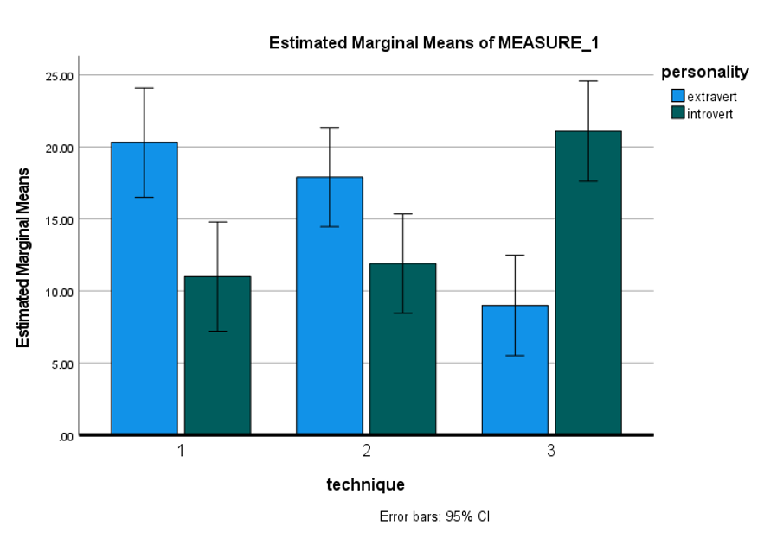
Profile Plots

