Health Behavior Assessment and Modification Project
Results and Reflection Form
Fill out the fields below. Note the word limits. Read all instructions carefully.
What behavior did your client choose to modify?
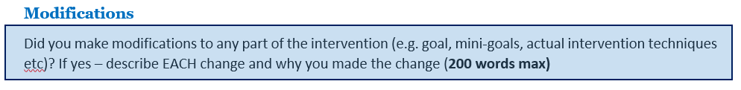

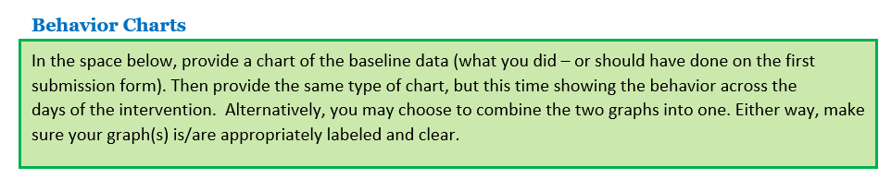

Results, Interpretation, and Reflection
You will need to meet with your client to get their perceptions of the intervention. Then answer the questions below.

How well did the intervention work? Address this from your client’s perception AND from an objective assessment of the data.

What part of the intervention helped your client the most? What was it about this particular part of the intervention that they found helpful?

What part of the intervention helped your client the least, or even made the target behavior worse? What was it about this particular part of the intervention that they found unhelpful or detrimental?

Knowing what you know now, what would you do differently next time? It’s okay to ask your client what they think.

Summarize what you learned from this entire project – the good, the bad, the ugly.

