Brain and Behavior Module 3 Quiz

Axons are specialized _____, while dendrites are specialized _____.
to communicate : for cell reproduction
for internal communication : for external communication
to receive neural signals : to send neural signals
to send neural signals : to receive neural signals

______ make the cell more positive ______ the likelihood it will fire.
EPSPs : increasing
EPSP : decreasing
IPSPs : increasing
IPSPs : decreasing

When a neuron fires ________.
the cell dies
a new cell is born
an action potential is generated
neurotransmitters in the synaptic space are reabsorbed into the cell

Agonists are substances which ________ neurotransmission, whereas antagonists _________ neurotransmission.
Facilitate : inhibit
Inhibit : facilitate
Facilitate : have no effect on
Inhibit : have no effect on

Which of the following statements about interneurons is FALSE?
Their axons are typically myelinated
They transmit information over very short distances
They are the most common type of neuron in the nervous system
They are used for localized communication

What happens when the action potential reaches the terminal button of the axon?
The pre-synaptic neuron dies (its job is done)
The action potential reverses direction and travels back up the axon
The neurotransmitters in the synapse are “called back” into the terminal button
Neurotransmitters are released

What important function do enzyme degradation and reuptake have?
They remove neurotransmitters from the synaptic cleft
They feed and nourish the cell
They make neurotransmitters
They protect and serve neurotransmitters, keeping them safe and warm

If you give an antagonist that affects an inhibitory neurotransmitter, the effect it will ultimately have on the post-synaptic neuron is:
To further inhibit the post-synaptic neuron
To disinhibit the post-synaptic neuron
It depends on which neurotransmitter you are talking about
“I knew I shouldn’t have dozed off in class for this!”

There is a limit to how rapidly a neuron can produce action potentials. This is due to __________
inhibition
facilitation
the absolute refractory period
the relative refractory period

When the action potential arrives at the terminal button, the entry of ____ ions stimulates the release of neurotransmitters.
potassium
calcium
sodium
chloride

Look at the diagram below and choose the option (a, b, c, or d) that correctly labels the letters on the diagram.

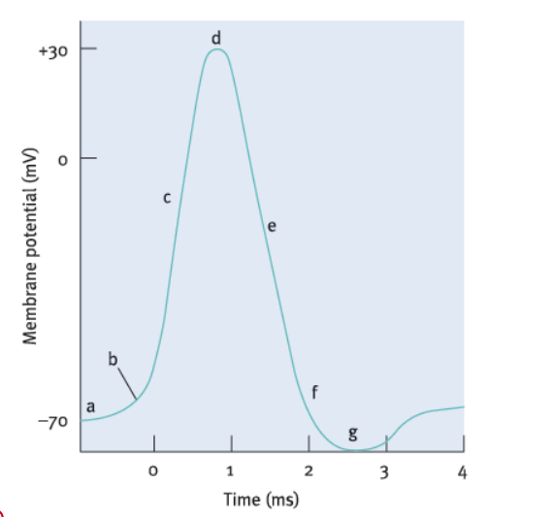
a depolarization c. sodium enters e. potassium enters g. resting potential
a. resting potential c. sodium enters e. refractory period g. depolarization
a. resting potential c. sodium enters e. potassium exits g. refractory period
a. chilling c. excitation e. coming down from a high g. in a slump
An inhibitory neurotransmitter causes the inside of the postsynaptic neuron to become ___
more positive
more depolarized
more negative
neutral in charge

What does the axon hillock do?
Adds up all the positive and negative charges to determine whether the cell will fire
Releases neurotransmitters
Glues the axon to the cell body
Whatever it pleases

When a myelinated cell fires, what happens under the myelinated sheath?
Hey – what goes on under the sheath is none of our business!
Business as usual – all the action is at the Nodes of Ranvier
Sodium diffuses down the inside of the axon, bringing the membrane to threshold at the adjacent Node of Ranvier
Ions continue to move in and out of their channels, we just can’t see them

Which of the following statements is FALSE? You will need to use your noggin for this one :)
Rarely will a single message from one neuron be sufficient to fire a cell
Temporal summation can increase or decrease the probability that the cell will fire
Spatial summation can increase or decrease the probability that the cell will fire
None of the above statements are false
The first three statements are all false

Why is it important for psychologists to understand how cells behave?
I dunno
cells behave much like people do, so understanding cells ultimately leads to a better understanding of people
cellular activity is the basis of some behaviors
cellular activity is the basis of all behavior

If an autoreceptor turns on, what effect will this have on neurotransmission?
Nothing
It will facilitate neurotransmission
It will inhibit neurotransmission
It will have an unpredictable effect on neurotransmission

Which of the following best describes salutatory conduction?
The action potential jumps from one node to the next
A series of action potentials sweeps down the axon, one at each node
One action potential saluts the other, stimulating it into action
It’s all a game of Dominos
What is a neurotransmitter "precursor"?
a substance that "gobbles up" neurotransmitters in the synapse
a substance produced by glial cells and that interacts with neurons
a substance used to make the neurotransmitter
my answer is censored for foul language

Which of the following best describes what is going on in people with multiple sclerosis?
glial cells in their nervous systems multiply out of control - this interferes with neural transmission
neurons spontaneously die in their nervous system which then can affect behavior at multiple levels
myelin is damaged and this slows down neurotransmission
neurotransmitters start to diminish in amount and type

How are chemical synapses different from electrical synapses?
chemical synapses are found in the CNS while electrical synapses are found in the peripheral nervous system
chemical synapses slow and specific; electrical synapses are fast and nonspecific
chemical synapses use metabotropic receptors; electrical synapses use ionotropic receptors
chemical synapses are like text messages; electrical synapses are like emails

Glial cell activity appears to be especially important for guiding and facilitating neural development ____
in response to damage in the CNS
in elderly people
in teenagers
during fetal development

What is responsible for building up the electrical potential in a neuron?
anions
sodium and potassium
the cell membrane and the ions "dying" to move through it
Duracells

Based on what was I talked about "in class", why is using psychotropic medications to treat people with a mental illness so challenging? Select all that apply.
most are patented and therefore very expensive
most doctors are inadequately trained on their use
each person has their own unique levels of neurotransmitters
you cannot affect one neurotransmitter without affecting others
many behaviors are independent of neurotransmitter function

